HOW TO GET AN ALABAMA SCHOOL BUS DRIVER CERTIFICATE

In order to receive an Alabama School Bus Driver certificate, a prospective school bus driver must meet the following requirements:

1. Receive a minimum of 15 hours of training from local school system transportation officials ***before***

enrollment in the SDE School Bus Driver Certification Class. Only drivers who receive this training 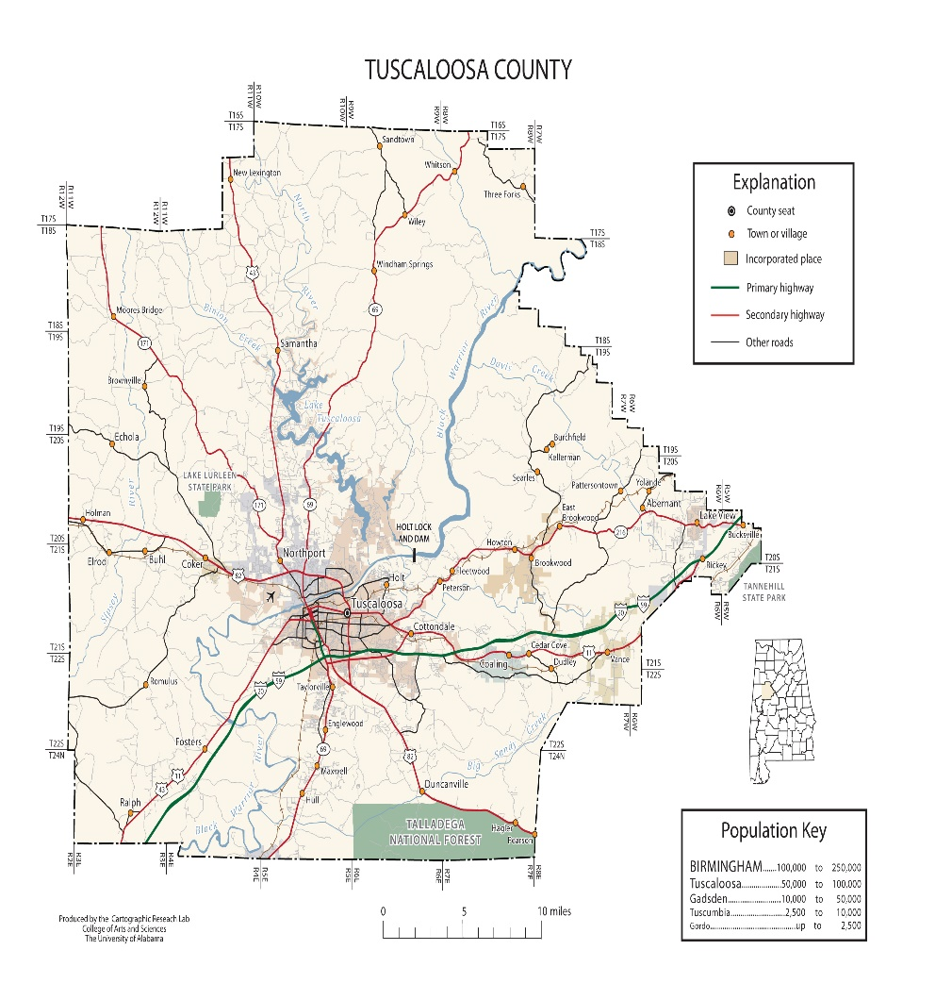

and produce a properly signed training certification form will be scheduled for performance testing.

1. Attend a 12-hour SDE New School Bus Driver Certification Class taught over a period of three days.

Normally, a portion of a fourth day is required for performance testing.

1. Score at least 80% on a written test given at the conclusion of the three-day class.
2. Pass a three-part performance test including:
   1. Pretrip inspection of a school bus with at least 80% mastery.
   2. Basic Control Skills Tests. These are backing and forward stop-line tests.
   3. On-the-road Driving Skills Test with at least 80% mastery.

In order to enroll in an SDE class and be performance tested, all prospective drivers must be assigned to the SDE new driver class by a local school system transportation supervisor. **All CDL performance testing for school bus drivers is done by the SDE.**

HOW TO KEEP AN ALABAMA SCHOOL BUS DRIVER CERTIFICATE

In order to maintain their school bus driver certification, school bus drivers are required to participate in a 4-hour recertification class. These classes are scheduled in all school systems and are taught between January 1 and October 31 annually. **All bus driver certificates expire annually on December 31.** Drivers who have attended a recertification class are issued an Alabama School Bus Driver Certificate for the next calendar year. Drivers who fail to attend a recertification class must repeat the new driver training. An Alabama School bus driver may have his/her Alabama School Bus Driver Certificate suspended and/or revoked when there is a danger to the public safety or welfare of school children or when the certificate holder has been guilty of immoral conduct or unbecoming or indecent behavior.  This includes, but is not limited to, confirmed improper drug use, criminal convictions, failure to use the driver seat belt, unsafe driving history, being uninsurable, or other just cause as determined by the state superintendent of education.